ZONTA CLUB OF COLUMBIA
NEWS AND VIEWS
QUARTERLY NEWSLETTER – WINTER 2013
www.zontaofcolumbia.com

Zonta Club of Columbia
Club # 513
Chartered, September 10, 1963

FROM THE DESK OF PRESIDENT
M. J. HASSELL

OFFICERS

President -- M. J. Hassell
Vice President --Marion D. Watson

Treasurer--Deborah Cornelison

Secretary -- Myriam Torres

Board Members
Committee Chairpersons

Fundraising-- Dottie Munsch

Board Member and
Membership-- Ellie Dagle

Board Member and
Public Relations -- Coretta D. Bedsole

Service -- Erin Long

District # 11 Representatives
District # 11 Governor
Tami Page (Dothan, AL)

Area O2 Director
Melodie Hunnicut (Columbia, SC)

President’s Page:
I hope everyone had a wonderful and relaxing holiday. I got to spend lots of time with Rabun (the most beautiful, smartest, and lovable baby ever). I now understand why Doris Cheek said being a grandmother would make me crazy.
By the time you read this, our Strategic Planning meeting will be upon us. I hope all of you will carefully read the results of the meeting and commit to working hard in the remaining months of this year and in the months and years to come. We have a great club and great opportunities to help women not just in the Columbia area but also worldwide.
The service committee will be calling on you to assist at Killingsworth. If you have been there, I don’t need to sell you on going again. If you haven’t, you don’t want to miss this opportunity. There will also be opportunities to be involved in selecting our YWPA and Jane Klausman scholarship winners. This is another wonderful chance to meet some outstanding young women. And who knows, we might also get a chance to recruit their mothers.
I’m pretty sure that the fundraising committee will be planning another Flea Market soon. We need both items to sell and workers. I promise to bring donuts – you are on your own for coffee. Not only do we get to recycle some of our stuff but we also get to buy at really reduced prices. I bought Doris Cheek’s pack’n play (playpen for us oldsters) last year and it has really come in handy.
There will also be an Area 2 meeting in Myrtle Beach sometime in April. Beach trip!!!! As soon as arrangements are made with the hotel, we will have a firm date. A little "Melodie" bird whispered in my ear that it could be the 13th.
And I need to put in a plea for you to be gathering your hours and amounts of money spent in service this past year from June 1, 2012 to May 31, 2013. Our report is only as valuable as the information you provide.
Thanks for all the hard work you do and your dedication to helping our sisters here and abroad.
M.J. Hassell
President
Zonta Club of Columbia

COMMITTEE MEMBERS
Finance and Fundraising
Doris Clevenger
Deborah Cornelison
Dottie Munsch
Barbara Scott

Membership
Ellie Dagle
M.J. Hassell

Public Relations
Coretta Bedsole
Ina Edens
Ann Maletic

Service
Judy Barnes
Doris Cheek
Melodie Hunnicut
Erin Long
Myriam Torres
Marion Watson

ZONTA WELCOMES NEW MEMBERS
Our new member Marilyn Matheus, was born in Charlotte and grew up in Cleveland, OH, the youngest of four siblings. She played violin throughout her school years and became active in community theater in Cleveland. She performed in many plays and musicals prior to winning a scholarship to study theatre at Kent State University, where she graduated with a BA in Telecommunications. Shortly after graduation she moved to SC to join her recently retired mother and oldest brother. (Two of her siblings reside in Columbia.)

Marilyn worked in radio for a short time before landing a temporary position publicizing children who were available for adoption through the SC Department of Social Services. This position grew into a full time position at the Department's Office of Public Affairs, where she is now the director of Constituent Services and Public Information.

In Marilyn's spare time she continues honing her theatrical skills and has been a member of the Trustus Theatre Company for 20 of its 25 years in existence. She serves on the Board of LRADAC and is a member of The Columbia Theatre Guild.

Marilyn's pride and joy is her daughter, Madison, who is now a freshman at American University in Washington DC. Madison was our most recent winner of the Katherine Matthew's Young Woman in Public Affairs Scholarship. Marilyn and Madison share their home with a beautiful beagle, Benediction or Bene and two cats, Mina and Minnie.

Martha Ann Williams, our club's new member, was born in Winchester, KY. She moved to Irmo, SC when her father retired from his position at the White House. She graduated from Irmo High School and Midlands Tech after which she worked as an LPN for ten years. Afterwards, she went into a new profession, Cosmetology, and has been active in the profession for 28 years. She has owned her own business since 1992.

Martha Ann has lived in the Earlewood neighborhood for 18 years where she owns her home. Her parents are still living, married to each other and are socially active. She has two brothers with large families, and Martha Ann has two dogs, Lillith and Lucy, each 6 years old.

She has been an active practitioner of Nichren Disashonins Buddhism for 26 years. The organization is called Sgi-USA, and is in 192 countries and active in the United Nations. She helped develop their youth program which has been active in three states for 18 years.

Martha Ann's pet peeve is when drivers fail to use their turn signals.

Several of her interesting career experiences include: serving on the hair fashion committee for SC for three years, working the runway for Perry Ellis fashion week in NYC in 1992, and assisting in teaching continuing education for cosmetologists.

The Zonta Club of Columbia welcomes Marilyn and Martha Ann and is excited they are joining us in our efforts to improve the status of women in SC and the world.

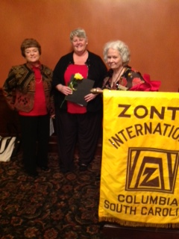
Ellie Dagle, Martha Ann Williams and MJ Hassell
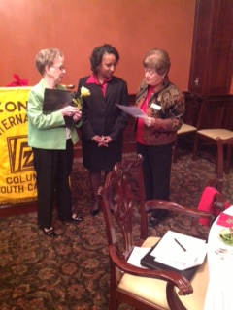
Doris Cheek, Marilyn Matheus and Ellie Dagle

MEMBERS AND FRIENDS
The Zonta Club of Columbia extends our deepest sympathies to Mr. and Mrs. Michael Edens (club member, Ina) on the loss of Mike’s sister. We also extend sympathies to former club member, Betty Jo Carson on the loss of her husband, Bill.

The club sends best wishes for a speedy recovery to the following members: Barbara Scott who continues her recovery and Doris Cheek who is battling a case of the shingles. Your Zonta sisters are thinking of you and wishing you well.

A ZONTA FOUNDATION NOTE
By Doris Larson, District 11 Foundation Ambassador

We had a great time at District Conference in beautiful Montgomery, thanks to the Montgomery Club and all the Clubs in Area 1. Attendees donated a total of $2,310.00 for Zonta International Foundation and with the addition of one-third of the District Fundraiser, the total was $3,030.00! Thirty-two individual Zontians donated at Conference with an average of about $72.00 each. Thank you so much.

As of October 31st, District 11 Zontians have sent $35,998.16 to Zonta International Foundation. Last year at the same time, District 11 had donated $20,764.61. At that time we two more clubs (we now have 42, and we had 85 more members (we now have 896) that's a 73% increase in giving. THANK YOU!

Here is how we rank among the other Districts:
- Overall 5th
- Amelia Earhart 9th
- Jane Klausman 3rd
- YWPA 6th
- International Service 6th
- ZISVAW 1st
- Rose 12th

If you have not yet donated individually to Zonta International Foundation, please consider doing so...it is so easy, just go to Zonta.org and click on the DONATE button. You can even set up an automatic withdrawal of any amount. It doesn't take a lot to add up over the years.

Another way to give is the Zonta Credit Card. Every time you use it, ZIF receives a percentage of the purchase, and it doesn't cost you anything. Consider adding a donation to ZIF in your will.

Thanks for all you do for Zonta.

ZONTA SERVICE RECOGNITION AWARD 2012-2014
The Zonta International Service Committee is pleased to announce the Zonta Service Recognition Award. The Award was established to recognize outstanding service projects undertaken by Zonta clubs or districts which benefit women in the local community. Service projects can be those projects that improve the status of women in general (legal, political, economic, educational, health and/or professional) or those projects that prevent and fight violence against women and girls. The best projects, as determined by the Zonta International Service Committee, will be exhibited during the 2014 Zonta International Convention in Orlando, Florida. A complete description of the Award, eligibility criteria and nomination process will be available soon on the Zonta International website.

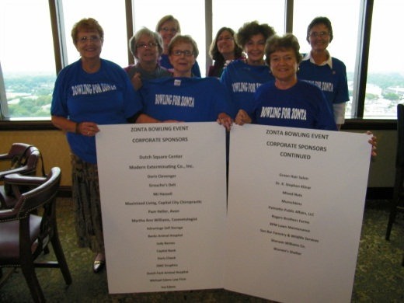
The Zonta bowling event helps make service possible. Club members thank the 2012 corporate sponsors for their support.

A REFRESHER ON DISTRICT # 11
District 11 is truly an international district composed of the Southeast United States, the Bahamas, Puerto Rico, and the British Virgin Islands. The states included are Alabama, Florida, Georgia, Mississippi, North Carolina, South Carolina, and Tennessee. The District is further divided into 6 Areas under which the individual Clubs operate. Area 1 includes the States of Alabama, Mississippi and Tennessee. Area 2 includes the States of Georgia, North Carolina and South Carolina. Area 3 includes the Bahamas, British Virgin Islands and South East Florida. Area 4 includes Central and Northern Florida. Area 5 includes Puerto Rico. Area 6 includes South West Florida.

ZI FOUNDATION
With the generosity and collective commitment of Zonta clubs and Zontians around the world, the Zonta International Foundation is making a difference in the lives of women and girls worldwide through our International Service projects, Zonta Strategies to End Violence against Women (ZISVAW) program, and educational award programs.

In Rwanda, Jean Claude Siboniyo is HIV-positive; however, thanks to family package services provided by Zonta International and UNICEF, his wife Claire and 17-month-old son Yves have not tested positive for HIV. "Nothing matches the happiness we enjoy in knowing that our baby is healthy," says Claire.

Thirty-five (35) Amelia Earhart Fellows are receiving financial support to continue their Ph.D./doctoral studies and specialized research each year.

Valerie Morgan, one of twelve 2012 Jane M. Klausman Women in Business Scholarship recipients, is pursuing her education towards a career in economic policymaking. At the same time, she volunteers with the International Rescue Committee, helping refugees prepare for the United States citizenship test.

Ga-Ram Kim is one of five 2012 Young Women in Public Affairs Awardees. As the main point of contact between her school and a South African organization that takes care of children orphaned or made vulnerable by HIV, Ga-Ram organizes and advertises the sale of products that the South African women make to raise money for the organization.

If you would like to help continue this wonderful work, go to this web link to make a tax deductible donation: https://zontafoundation16394.thankyou4caring.org/page.aspx?pid=291

Membership Recruitment Is For Everyone
To continue our good work the Zonta Club of Columbia needs members. Consider using one or more of these sources as a place to recruit club members. Membership recruitment is everyone’s responsibility.

- Advocacy groups
- Chambers of Commerce
- Churches and religious groups
- Conferences/Special Events
- Military units and retired military personnel
- New residents of the community
- Senior citizen groups
- Trade Associations
- United Way
- University/college organizations

Killingsworth Fashion Show
The annual Killingsworth Fashion Show is proof positive Zontians can have fun while raising money. What great fun we had at the November 2012 event! Thanks to Erin Long for serving as our model. She was a natural.

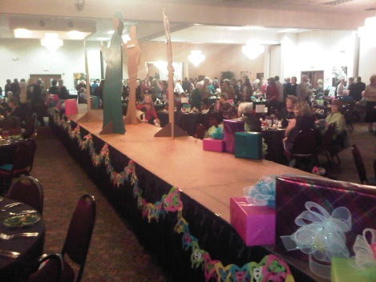 Erin preparing for the fashion show with assistance from her sister.
